**REVIEW UTS DATABASE ORACLE**

Hubungan antar entity, Primary key, dan Foreign key dari ke 5 tabel dan

Menggunakan syntax query dari Pak Mazmur Tarigan

|  |
| --- |
| Product |
| Product ID (PK) |
| Product Name |
| Category |
| Buy Price |
| Sell Price |
| Product Image |
| Description |

|  |
| --- |
| Order |
| Order No (PK) |
| Customer (FK) |
| Date |
| Is Deliver |

|  |
| --- |
| Stock |
| Product Name (FK) |
| Quantity |
| Date |
| Stock By |

|  |
| --- |
| Order Details |
| Order No (PK) |
| Product Name (FK) |
| Quantity |

|  |
| --- |
| Customer |
| Cust ID (PK) |
| First Name |
| Middle Name |
| Last Name |
| Shipping Address |
| Email |
| Contact |

**QUERY**

% Menampilkan dan melihat deskripsi 5 table yang sudah dibuat sesuai perintah di papan tulis %

SELECT * FROM PRODUCT_NOV

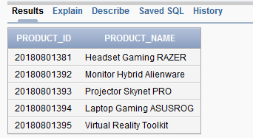

SELECT * FROM ORDER_NOV

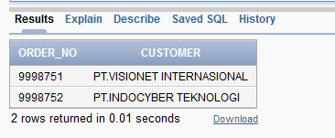

SELECT * FROM CUSTOMER_NOV

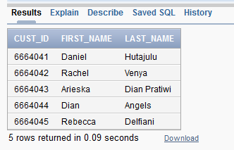

SELECT * FROM ORDER_DETAILS_NOV

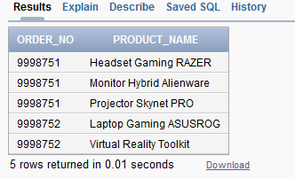

SELECT * FROM STOCK_NOV

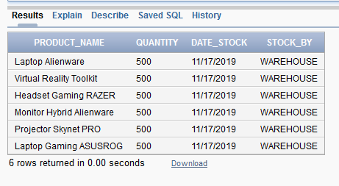

DESC PRODUCT_NOV

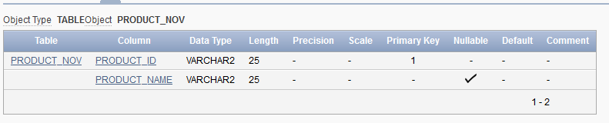

DESC ORDER_NOV

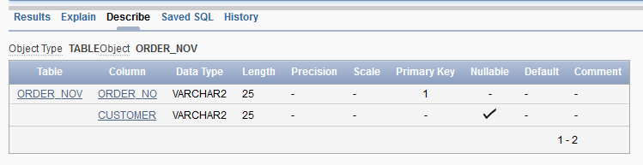

DESC CUSTOMER_NOV

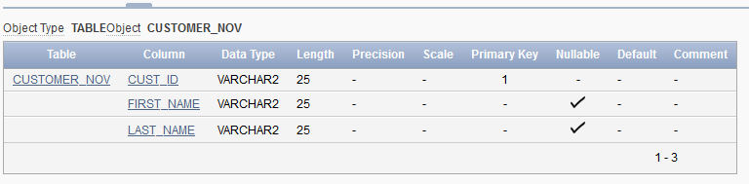

DESC ORDER_DETAILS_NOV

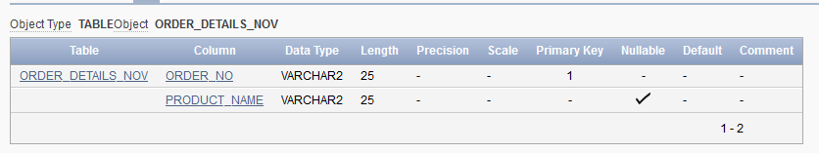

DESC STOCK_NOV

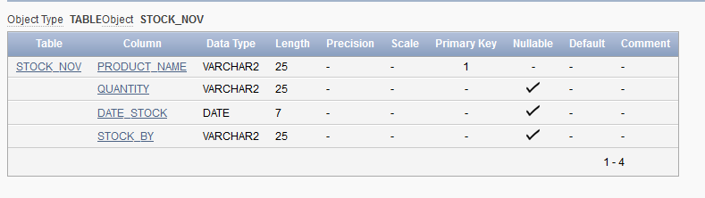

// --- //

**SOAL NO 6**

**TAMPILKAN DATA TRANSAKSI**

**SELECT** A.ORDER_NO, A.DATE, C.FIRST_NAME, B.PRODUCT_NAME, B.QUANTITY, D.SELL_PRICE, B.QUANTITY*D.SELL_PRICE **AS TOTAL**

**FROM** ORDER_NOV A, ORDER_DETAILS_NOV B, CUSTOMER C, PRODUCT D

**WHERE** B.ORDER_NO = A.ORDER_NO AND **C.CUST_ID = A.CUSTOMER** AND D.PRODUCT_NAME = B.PRODUCT_NAME

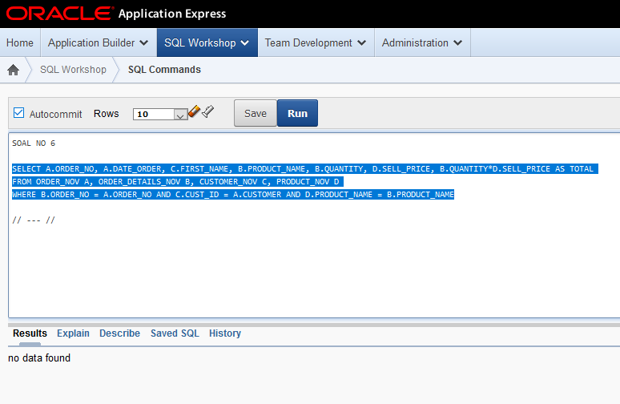

// --- //

**SOAL NO 7**

**TAMPILKAN PRODUK TERBANYAK DIJUAL**

**SELECT** PRODUCT_NAME, SUM(QUANTITY)

**FROM** ORDER_DETAILS_NOV

**GROUP BY** PRODUCT_NAME, QUANTITY

**ORDER BY** QUANTITY DESC

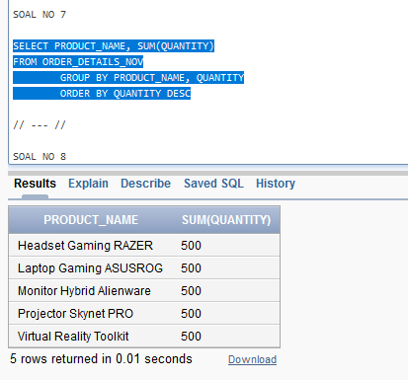

// --- //

**SOAL NO 8**

**TAMPILKAN PRESENTASI PENJUALAN TIAP HARI UNTUK MASING-MASING PRODUK**

**SELECT** A.DATE, B.PRODUCT_NAME, SUM(B.QUANTITY),

PERSENTASE = (SUM(B.QUANTITY)/

SELECT SUM(D.QUANTITY)

FROM ORDER_NOV C, ORDER_DETAILS_NOV D

WHERE D.ORDER_NO = C.ORDER_NO AND C.DATE = '2019-11-16')*100

**FROM** ORDER_NOV A, ORDER_DETAILS_NOV B

**WHERE** B.ORDER_NO = A.ORDER_NO AND A.DATE = '2019-11-16'

**GROUP BY** A.DATE, B.PRODUCT_NAME, B.QUANTITY

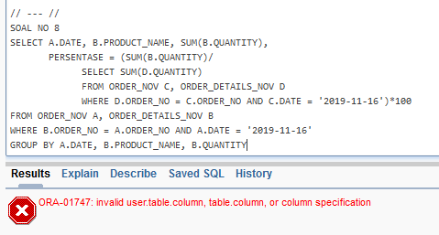

// --- //

% Syntax untuk menambahkan data pada **kelima** table %

SELECT * FROM PRODUCT_NOV

**INSERT INTO** PRODUCT_NOV

**VALUES**('20180801395','Virtual Reality Toolkit');

**INSERT INTO** PRODUCT_NOV

**VALUES**('20180801396','Headset Gaming RAZER');

**INSERT INTO** PRODUCT_NOV

**VALUES**('20180801397','Laptop Alienware');

SELECT * FROM ORDER_NOV

**INSERT INTO** ORDER_NOV

**VALUES**('9998751','PT. VISIONET');

**INSERT INTO** ORDER_NOV

**VALUES**('9998752','PT. INDOCYBER TEKNOLOGI INDONESIA');

SELECT * FROM CUSTOMER_NOV

**INSERT INTO** CUSTOMER_NOV

**VALUES**('6664045','Rebecca','Delfiani');

SELECT * FROM ORDER_DETAILS_NOV

**INSERT INTO** ORDER_DETAILS_NOV

**VALUES**('9998751','Headset Gaming RAZER');

SELECT * FROM STOCK_NOV

**INSERT INTO** STOCK_NOV

**VALUES**('Laptop Alienware','500','11-17-2019','WAREHOUSE');

**INSERT INTO** STOCK_NOV

**VALUES**('Virtual Reality Toolkit','500','11-17-2019','WAREHOUSE');

**INSERT INTO** STOCK_NOV

**VALUES**('Headset Gaming RAZER','500','11-17-2019','WAREHOUSE');

**INSERT INTO** STOCK_NOV

**VALUES**('Monitor Hybrid Alienware','500','11-17-2019','WAREHOUSE');

**INSERT INTO** STOCK_NOV

**VALUES**('Projector Skynet PRO','500','11-17-2019','WAREHOUSE');

**INSERT INTO** STOCK_NOV

**VALUES**('Laptop Gaming ASUSROG','500','11-17-2019','WAREHOUSE');